Admin Sports Book

Product Name:
Project Name:
Project ID:
Project Manager:

Document Version: | 00.01
Release Date: | 28/02/2007

Approval by:
# | Full Name | Position
1
2

Revision History
# | Date | Version | Author | Review | Description/Changes
1 |  | 00.01 |  |  | Initial draft version
2 |  | 01.00 |  |  | The approval initial version

Table of Contents
Revision History 2
1. Introduction 4
2. Structure 4
Home Page: 4
3. Functionalities 4
A. Admin Log in/Log out 4
B. Admin Information 5
1. Live Controller 5
2. Total Bet 10
3. Users: 13
4. Event 13
5. Setting: 13
6. Tools 13
7. Statistic 13
Appendices 13

1. Introduction

The major purposes of this document are to explain the main functionalities of the admin site. In order to appoint users, show up-to-the-minute different reports, control odds, manage events, accept or delete tickets and take a position are the most important points that I would like to emphasize here. The purposes are illustrated below.

2. Structure

Home Page:
Top Menu
  - Live Controller
  - Total Bet
  - User
  - Event
  - Setting
  - Tools
  - Statistic
  - Change Password
  - Log Out

3. Functionalities

A. Admin Log in/Log out
- Log in
- Browse to http://tadmin.ibc88.com/.
- Enter UserName and Password in the Log-in page and then click the Login button.
- Check and approve UserName and Password. If log-in fails, the user is allowed to try again to access the system.
- Log out
- If user wants to leave the system, clicks on Logout menu to end/clear existing session.
- After process of log-out is successful, user is automatically redirected to the log-in screen.

B. Admin Information

Live Controller

Allows the authorized user to control various settings, the goals or odds for each match, and accepted or rejected waiting bets, for each particular Handicap, Over and Under bet type. By default Live Controller contains the four sessions related with each match status; Running, Closed, Finished and Settled. Naturally the name of the mach status makes the clearest indication of the match progress. For further information regarding the Live Controller, see Figure 1 below:

Definitions:
Handicap (HDP): The favorite team will be the team that is giving the handicap and the weaker team will be the one that is receiving the handicap
Goal: Predicting the total amount of goals scored (Over or Under) in a match irrespective of favorite or weaker teams.
Over/Under: The outcome of the game depends on the striking ability of the strikers from teams, the defense, their motivation and strategy. It is up to you to predict the probable outcome and decides on betting Over or Under.
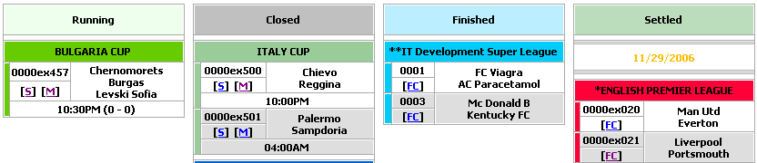
1
2
3
4

Figure 1: Live Controller

[1] “Running” contains the matches which are running (open for member betting).
[2] “Closed” contains either games which are not opened yet or just closed half way while Live games are being running or games which are just finished as time frame to consider is 2 hours before pass to finished.
[3] “Finished” is specified the matches just ended but they are still unsettled.
[4] “Settled” contains the matches which are finished, usually calculated win/loss income for customers.

Note: as usual, soccer game is 90 minutes + a bit of break (15 minutes). So if CSD settles game fast enough, the game won't go to finish, but right away go to Settled.

By just clicking the “M” link, the following Figure 2 provides a place where the authorized user can control the suspension matches for whatever reasons at any times. During a LIVE game the Over/Under handicap will reflect the current scores of the game. The handicap may be higher or lower depending on the in-running result during the LIVE game.

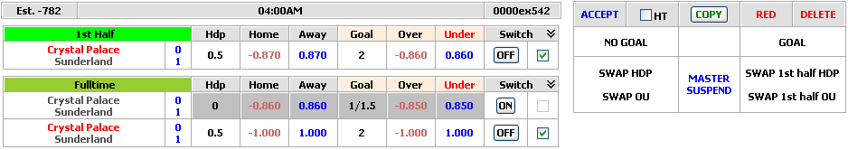

Figure 2: Control Suspension Matches

- 1st Half betting applies to the 1st half of play ONLY. Bets are settled based on the score of the end of the scheduled “45 minutes”, including any added injury time.
- Full Time betting applies to the full “90 Minutes Play” of the entire match. Bets are settled on the score of the end of the scheduled “90 minutes” including any added injury or stoppage time.
- Switch: control the games closed or opened.
- Accept: accept all 1st half and fulltime waiting bets.
- Copy: copy odds from dead ball to live ball.
- Red: by default the spread is usually 0.08. When a red card appears during the match, the user can click the RED button to change the spread to 0.10. Note that waiting bets will be deleted. If spread is 0.10, it will not change.
- Delete: reject all 1st half and fulltime waiting bets.
- Goal: when there is a goal shouted by any team, the user will use this function to suspend the odds (odds appear to wagers but wagers can not place bet).
- No Goal: used to verify that new goal has been processed.
- Swap HDP: support to swap two sets of odds and handicap for the Full Time Handicap bet type.
- Swap OU: support to swap two sets of odds and handicap for the Full Time Over/Under bet type.
- Swap 1st half HDP: support to swap two sets of odds and handicap for the first half Handicap bet type.
- Swap 1st half OU: support to swap two sets of odds and handicap for the first half Over/Under bet type.
- Master Suspend: odds appear to wagers but wagers can not place bet. When a market is suspended, any bets entered will be rejected. In case of suspension, the final score will be the score at the point of suspension providing the match has been played for at least 43 minutes. If the match was SUSPENDED, ABANDONED, or ABORTED during the 1st half, all bets placed on 1st half will be considered as VOID. If the match was SUSPENDED, ABANDONED, or ABORTED during the 2nd half, all bets placed on 1st half will still be considered as VALID and all 2nd half bets will be considered VOID.

LIVE Betting Rules:
- Due to LIVE matches being broadcast via satellites, there will be a delay in TV transmission. The delay varies from the TV channels you're watching as well as your location. Customers agree that all bets placed during LIVE betting shown in Bet List or Statement will be considered as valid. We will not consider the time of goal shown on ANY live score websites as evidence for disputes.
- Where we have reason to believe that a bet is placed after the outcome of an event is known, or if delayed ‘live' TV coverage results in a bet being placed at the incorrect price after the selected participant/team have gained a significant advantage, we reserve the right to void the bet, win or lose.
- In the event of malfunctions of our betting system crash or our internet connection, we reserve the right to cancel all pending bets placed at the time of the incident.

Odds Setting: There are two types of odds setting Change setting Fulltime/1st Half HDP and Change setting Fulltime/1st Half Over/Under like figure 3 below.

- Odds Statuses: all odds situations for each match.
Running: odds appear to wagers and then wagers are able to bet in.
Suspend: odds appear to wagers but wagers can not place bet.
Closed: odds do not appear to wagers.
Internal: odds do not appear to wagers, but still appear in the Admin’s Phone Betting area. Therefore, the Admin user will be able to key tickets in. This status will be used when we want to close odds for wagers but still need to key some “hedge” bet information into system.
- Event: Show the team names of the match.
- Handicap: The odds between Home and Away
  - Home gives odds to Away. For example 1 - 0, it means the Home gives odds 1 to Away
  - Away gives odds to Home. For example 0 - 0.5, it means the Away gives odds 0.5 to Home
- Group: Support the Spread, instead of asking users to enter for every spread, they just need select the value in Group drop down list and then it will affect all Spreads and Gap Odds of Home and Away. If the bets encounter to the Risk value, administrators will set the Gap Odds.H or Gap Odds.A to the event. Otherwise the administrator will set the Gap Odds(R).H or Gap Odds(R).A to event when the bet encounter the Stake Range value. This helps company creation the betting balance from members to Home and Away in order to avoid lose profit on the event.

Note. The Gap Odds.H and Gap Odds.A always are lower than Gap Odds(R).H and Gap Odds.(R).A

Example: In the Figure below, event England U21 – Spain U21, Group value is 7 so the Spread set will start from 0.7 for Spread a, 0.8 for Spread b and so on. Risk and Stake Range

- Spread is gap between home odds & away odds. The wider spread takes; the more profit company may gain. Spread b will be wider than a, c will be wider than b and so on. So spread group will relate to commission. If group b gives more commission than group a, company can gain more profits by spread range.
- Balance: The additional betting amount of customers. Admin based on this value to consider whether increase or decrease the odds for each event, user can set Auto bookie for changing the odds. The balance value will be manually equal to 0 when each time the auto bookie appears.
- Max Bet: The maximum amount which allows the wagers can bet per bet.
- Risk (H): the limitation to set Auto Bookie for Home team.
- Risk (A): The limitation to set Auto Bookie for Away team.
- Stake Range (H): The stake range that admin set for Home if the total bet of member over this limitation. The system will automatically use the Gap Odds(R) for Home team.
- Stake Range (A): The stake range that admin set for Away if the total bet of member over this limitation. The system will automatically use the Gap Odds(R) for Away team.
- Gap Odds A: The gap odd is set for Away team.
- Gap Odds H: The gap odd is set for Home team.
- Gap Odds (R).A: The risk gap odd is set for Away team.
- Gap Odds (R).H: The risk gap odd is set for Home team.
- Min Odds: the lowest value which admin sets for decrease the odds.
- Max Odds: the highest value which admin sets for increase the odds.

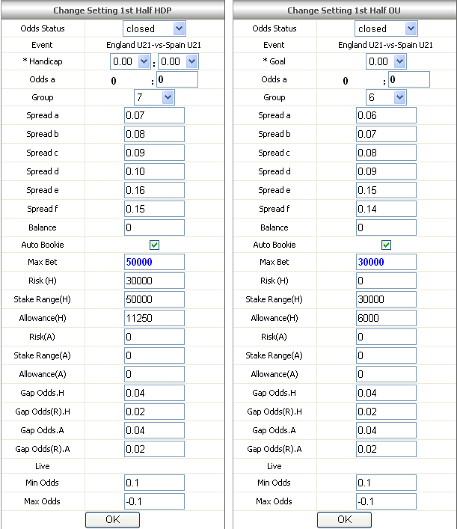

Figure 3: Odds Setting

There are 2 categories of bet type.
1. Bet type with spread concern (mean different groups will see different odds).
2. Bet type without spread concern (all members under different groups will see the same price).

Full Time Waiting Bets
The following Figure 4 shows the potential win/loss position on each live match for Full Time Handicap. (-) sign means that company is taking the Away team. The total potential Handicap will be calculated based on the stakes placed by each wager.
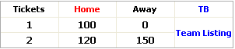
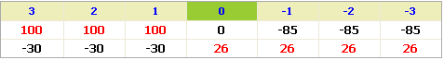
1
2
3
4
5
6
7
8
10
9

Figure 4: Full Time Handicap Forecast
[1]: Total accepted bets.
[2]: Value of total bets for Home team accepted by the admin.
[3]: Value of total bets for Away team accepted by the admin.
[4] TB: show the detailed total bets of each specified match.
[5]: Total waiting bets.
[6]: Value of total bets on Home team waiting for the Admin to accept or reject.
[7]: Value of total bets on Away team waiting for the Admin to accept or reject.
[8] Team Listing: show the detailed bet lists for Handicap bet types.
[9]: potential win/loss position for a particular match under different score scenarios while all bets are accepted by the company. The formula: Handicap Total (Accepted/Waiting) = Home Team – Away Team (also applied for 1st 45min HDP Total).
[10]: potential win/loss position for a particular match on bets which are waiting for the Admin to accept or reject.

The following Figure 5 shows the potential win/loss position on each live match for Full Time Over/Under bet type. (-) sign means that company is taking the “Under”. The total potential Over/Under will be calculated based on the stakes placed by each wager. The formula: Over/Under Total (Accepted/Waiting) = Over – Under (also applied for 1st 45min Over/Under Total). Note: Betting on Over/Under is different from Handicap as it takes into account the total amount of goals scored by both teams rather than one team.

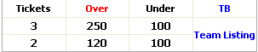
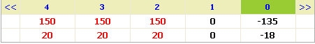
1
2
3
4
5
6
7
8
10
9

Figure 5: Full Time Over/Under Forecast

[1]: Total bets accepted.
[2]: Value of total bets on Over accepted by the admin.
[3]: Value of total bets on Under accepted by the admin.
[4] TB: show the detailed total bets of each specified match.
[5]: Total bets waiting.
[6]: Value of total bets on Over waiting for the Admin to accept or reject.
[7]: Value of total bets on Under waiting for the Admin to accept or reject.
[8] Team Listing: show the detailed bet lists for Over/Under bet types.
[9]: potential win/loss position for a particular match under different score scenarios while all bets were accepted by the company.
[10]: potential win/loss position for a particular match if all bets in waiting are accepted or rejected by the company.

The following Figure 6 displays much useful information regarding the 1st half and Full Time waiting bet lists placed by wagers. The formula to calculate Amount is: Amount = stake * %com.pos.

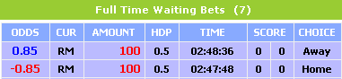

Figure 6: Full Time Waiting Bets
1st Half Waiting Bets refers to Full Time Waiting Bets.

2. Total Bet

The main purpose of this part is that helps administrators control the risk more convenient according to Bet type: The bet type category includes Handicap, Over/Under, 1st HDP, Total corners, Substitutes Used, Clean Sheet, First/ Last Goal, and HT/FT.

Handicap: The system will display all leagues which members bet on Handicap type. User can view all or just some leagues.

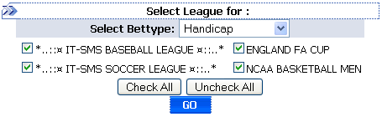
Figure 7: Select Bet type

After click on Go button the detail information relates to Handicap bet type will be displayed.

[1] No: Present the transaction identification for each event. When click on the No, the Forecast for the event will be shown. Whenever admin changes the score for the event, the odds also change.

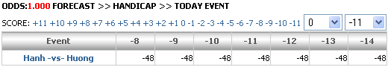
Figure 8: Forecast form Score

[2] Home: Show the Home team name. The detail total bet by odds will display when user clicks on Home team name like figure 6 below.

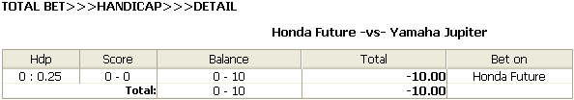
Figure 9: Total Bet by Odds

[3] Away: Include the Away name.
[4] Balance: The amount stake that members bet on Home and Away. When click on the Balance link the match event in detail will be display like Figure 10.
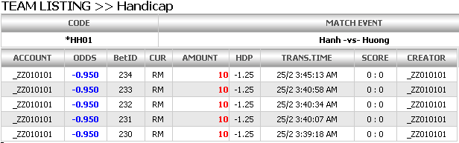
Figure 10: Team listing

[5] Total: The total amount balance which members bet on Home and Away.
[6] Bet On: the team name which members bet on.
[7] No: Content the game show time when click on that the Edit Match page will be displayed like figure below. Authority Admin can edit odds for the match information.

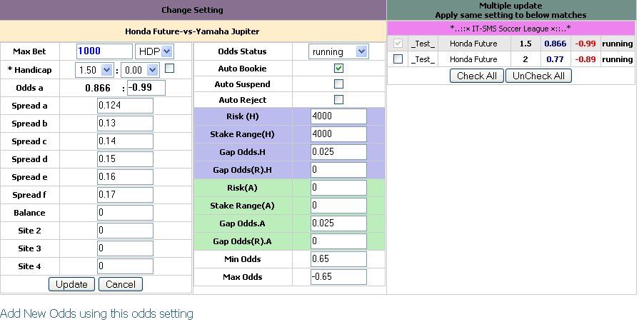

Figure 11: Edit Match

[8] Event: The name of team which member bets on.
[9] Goal: Allow authority administrators change the given between home and away.
[10] Fav: Favorite team, show the odds of team which believed to be the most likely winner.
[11] Und: Underdog team that, according to the odds, is the weaker or among the weakest in a given match-up, or is regarded as such by the betting public. Administrator can change the odds of Underdog team.
[12] Status: The game status is Closed, Running, Suspend, or External.
[13] Balance: The risk of company. Authority administrators can set the new balance for the event.
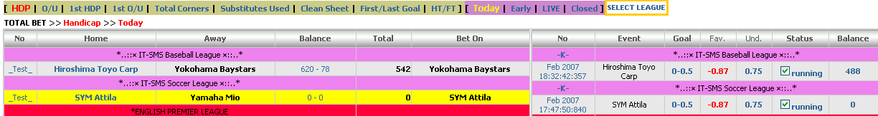
1
2
3
4
5
6
7
8
9
10
13
12
11
Figure 12: Handicap bet type

Over/Under: The system displays all leagues which members bet on Over, Under type, refer to Handicap bet type for more detail.
1st HDP: The system displays all leagues which members bet on 1st handicap type, refer to Handicap bet type for more detail.
Total Corners: The system will display the leagues and then show the Total Corners information for each event of leagues which users have chosen and then set the odds for this bet type. The Edit Match Corner page allows administrator to edit the odds when he click on Date Time link.

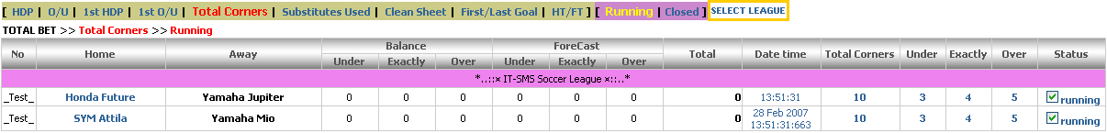

Figure 13: Total Corners

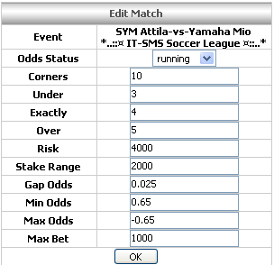

Figure 14: Edit Match Corners.

Substitutes Used: Allowance authority admin control the risk for Substitutes Used bet type. Admin can set the odds directly on the Substitutes Used page or click on Date Time link to display the Edit Match Substitutes Used page like Figure 12.

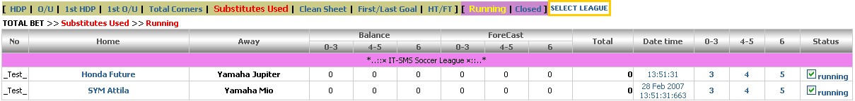

Figure 15: Substitutes Used

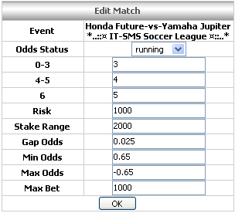
Figure 16: Edit Match Substitutes Used

Clean Sheet: This function allows admin control the risk for Clean Sheet bet type. Admin can edit directly on Forecast of Home and Away or click on Date Time link to show the Edit Match Clean Sheet odds like Figure 13. Members can bet on which team can keep clean sheet during the show time.

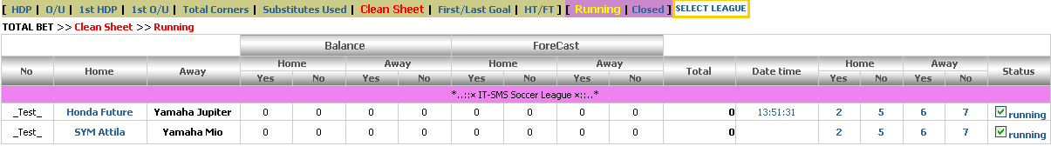
Figure 17: Clean Sheet

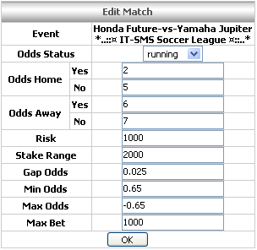
Figure 18: Edit Match Clean Sheet

First/Last Goal: set risk for match according to the number of goals that teams have kicked. Admin can set directly on the First/Last Goal page or click on date time link to show the Edit Match Odds (Figure 16).

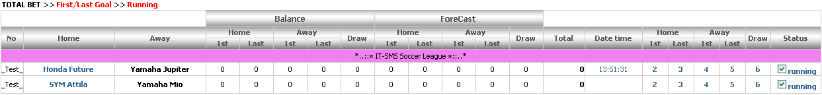
Figure 19: First/ Last Goal

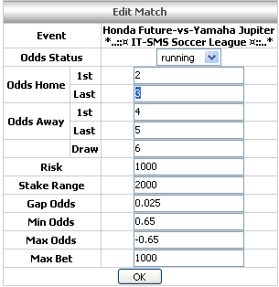
Figure 20: Edit Match Odds

HT/FT: Allow admin sets the odd for betting which teams will win in the Half Time and Full Time.
HH: In the first half time and full time, Home team wins.
HD: In the first half time, Home team wins but full time Home and Away teams draw.
HA: In the first half time, Home team wins but full time Away team wins.
DH: In the first half time, Home and Away teams draw but full time Home team wins.
DD: In the first half time and full time, Home and Away teams draw.
DA: In the first half time, Home and Away teams draw but in full time Away team wins.
AH: In the first half time, Away team wins but in full time Home team wins.
AD: In the first half time, Away team wins but full time Home and Away teams draw.
AA: In the first half time and full time, Away team wins.

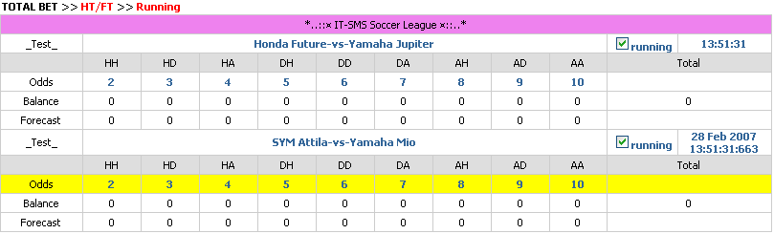
Figure 21: Half Time/ Full Time

Note: For Handicap, O/U, 1st HDP bet type, the Total Bet has function that allows user to view by Today, Early, and Live.

3. Users:
- Add Member: Specify the agent of member first by keying the Agent’s username and then click Next button to continue. Refer to “DSA_Agent_Sports_Book” to see the way to set the Commission and Position taking for member.

- Add Agent: Determine the master for the new agent, and then press Next button to continue. Refer to “DSA_Master_Sports_Book” to see the way to set the Commission and Position taking for agent.

- Add Master Agent: Define the Super of Master Agent. User can choose the Super or Company direct for master agent.
- Super: Specify the super line of master agent from the Super category.
- Company direct: Identify that the master agent will be managed by Company. Company plays as Super role.
  - Currency: The currency type which master and down line account will use.
  - Site: Specify site that its members can access such as 777GOAL, IBSBET, or IBSCOM and so on.
- Next button directs user to Add New Master form. Refer to “DSA_Super_Sports_Book” to see the way sets the Commission and Position taking for master.

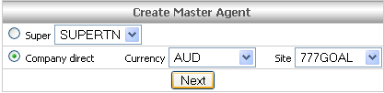
Figure 22: Create Master Agent

- Add Super Agent: Admin can create new super via Add New Super
- Super Info:
User Name: the name the super uses to login to the system.
Password: specify the password which super can login to the system.
Contact Info: specify the account information of super such as First Name, Last Name, Phone number, and Mobile number.
Site: set the site that allows all down line accounts of this super access.
Currency: the currency that user for super and all its down line accounts.
Super Max Credit: The credit account for super. The lower down line account (Master) will base on this number to create Master credit account, it can’t over this number.
- Commission: provides category commission groups. Super is applied to all types of Asian Handicap, Over/Under, Odd/Even, 1x2, total Goal, Correct Score and Mixed Parlay bets.
Group A: 0.0025, 0.002, 0.0015…; Group B: 0.005, 0.0045, 0.004…
Group C: 0.0075, 0.007, 0.0065…; Group D: 0.01, 0.0095, 0.009…
Other Comm: 0.05, 0.045, 0.04…
- Soccer
Min Bet: minimum bet amount that the super uses to set for his masters.
Max Bet: maximum bet amount that the super uses to set for his masters.
Max Per Match: Maximum bet per match amount that the super uses to set for his masters.
- Basketball
Min Bet: minimum bet amount that the super uses to set for his masters.
Max Bet: maximum bet amount that the super uses to set for his masters
Max Per Match: Maximum bet per match amount that the super uses to set for his masters.
- Soccer Position Taking:
Super Max Position (applied for dead ball): is represented for super max position taking value that will be affected on whole lines (super + master + agent).
Master Max Position (applied for dead ball): is represented for master max position taking value that will be affected on master and agent levels.

Agent Max Position (applied for dead ball): represented for agen max PT value that will be affected on agent level.
Copy from Handicap: check the “Copy from Handicap” box to get the same position taking value like Handicap for the rest of bet types such as Over/Under, 1st Hdp, 1st O/U, and Odd/Even.
Copy from 1x2: Check “Copy from 1x2” box to get the same position taking value like 1x2 for the rest of bet types such as Correct Score, Total Goal, Mix Parlay, and Outright.
Super Max Live Position (Applied for running betting)
Master Max Live Position (Applied for running betting)
Agent Max Live Position (Applied for running betting)
Copy from Handicap: check the “Copy from Handicap” box to get the same position taking value like Handicap for the rest of bet types such as Over/Under, 1st Hdp, 1st O/U, and Odd/Even.
- Basketball Position Taking
Super Max Position: is represented for super max position taking value that will be affected on whole lines (super + master + agent).
Master Max Position: is represented for master max position taking value that will be affected on master and agent levels.
Agent Max Position: is represented for agent max position taking value that will be affected on agent level.
Copy from Handicap: check the “Copy from Handicap” box to get the same position taking value like Handicap for the rest of bet types such as Over/Under, 1st Hdp, 1st O/U, and Odd/Even.
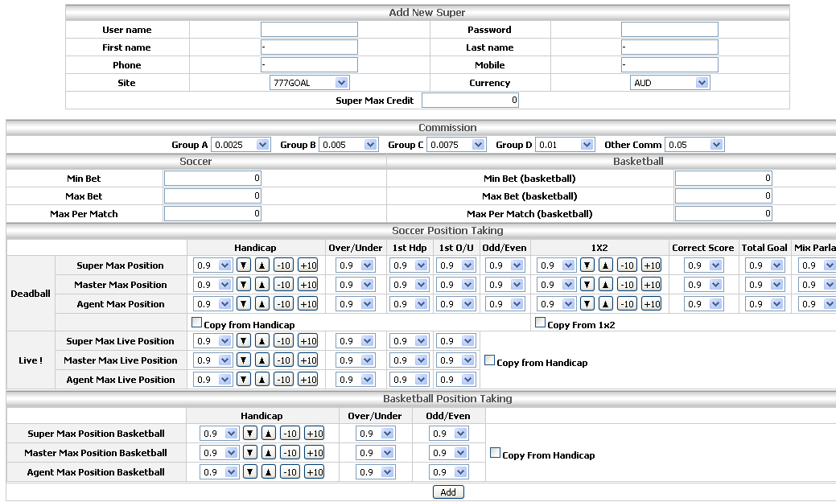
Figure 23: Add New Super

- Master Agent List: This shows all masters which manage direction by company. User can view Master Agent List by Currency or Status.
Currency: This category allows users to view master lists according to currency for instance AUD, JYP, RM, or RMB.
Status: This category allows users to view master list according to Status, All, active, or closed masters.

After click “Go” button, the Master list will be presented like Figure 24


1
2
3
4
5
6
8
9
7

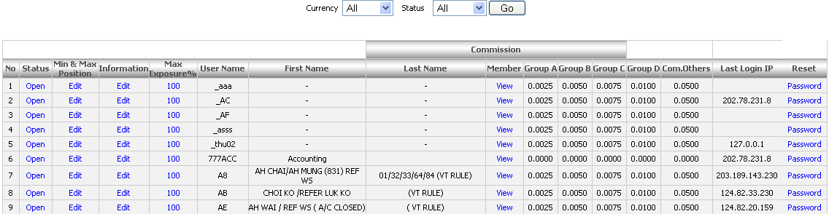

Figure 24: Master Agent List

[1] Status: Show the Edit Master Agent Information which allows administrator edits master information. Refer to “DSA_Master_Sports_Book” – Edit Master Agent for deeply guidance.
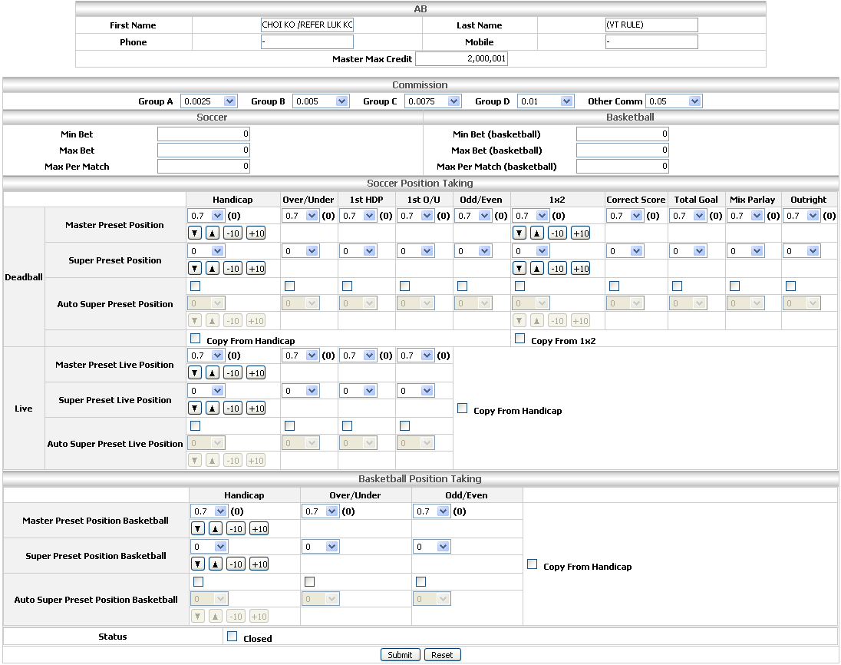

Figure 25: Edit Master Information

[2] Min & Max Position:
Min Position: is minimum position taking that the admin intends to limit for each specified master agent. The select valued values of Min Position are 0, 0.05, 0.1, 0.15, 0.2…. 0.6 because the super agent SA-NTD refers to take 0.6 Master Preset Position for that specific master agent “AB”. In this case, the admin intends to take 0.2 Min Position for that master agent (see figure 23 below)
Max Position: is max position taking value that the admin intends to limit for each specified master agent. The optional values of Max Position are 0.6, 0.65, 0.7… 0.9 because super agent “SA-NTD” refers to take 0.6 Master Preset Position for particular master agent “AB”. In this part, the admin intends to set 0.9 Max Position for that master agent (see Figure 24 below)

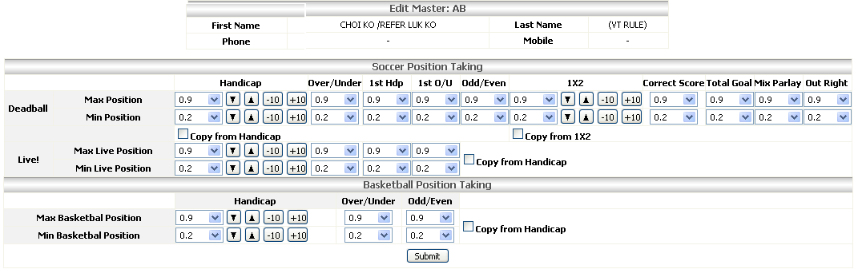

Figure 26: Edit Min & Max Master Position Taking

[3] Information: Allow administrator editting specify master agent information for instance First Name, Last Name, Email… etc (see figure below).

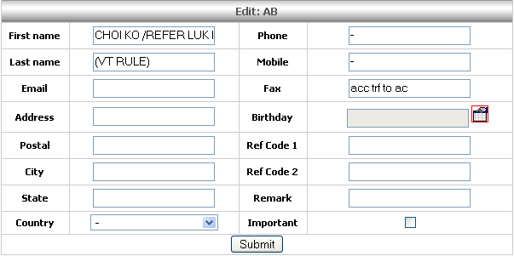

Figure 27: Edit Master Information

[4] Max Exposure %: set percentage credit which member can bet per match. This value will affect to exposure value of Agent.
For Example: The master “AA” has credit 1000 which max exposure is 30%; the maximum stake his member can bet for the math is 300.
[5] Master Info: Show general master information which includes User Name, First Name, and Last Name
[6] Member: when click on View link, the system will show all agents down line account of that master. If the agent has members, click on View of member column to list members.
[7] Commission: Show the group commission of master agent: Group A, Group B, Group C, Group D, and Others commission.
[8] Last Login IP: Include the ip address which last time that master agent login to the site.
[9] Reset: Allowance to change the password of specific master agent.
Password: Key the new password.
Confirm password: reenter the password.

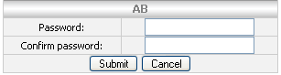

Figure 28: Reset Password

- Super Agent List: Refer to Master agent list
- Suspend: Specify the suspend member. When we suspend this member, the matches which member betted will be automatically suspended and other members can’t bet on this match. The suspend process follows these steps.
- The page will show the Master level first when user clicks on Suspend link. Choose the down line account of Master by clicking on List Agents link.

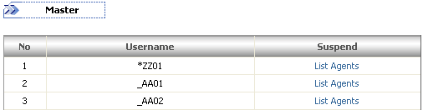
Figure 29: Master Level

- The Agent list will be presented when user clicks on List Agents link which Username is *ZZ0101 the down line account of *ZZ01.
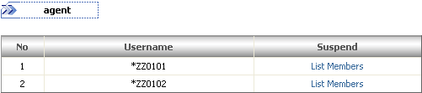
Figure 30: Agent Level

- Identify the Member which administrators want to suspend having Username *ZZ0101001, the down line account of *Z.Z0101.
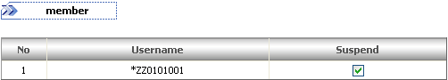
Figure 31: Member Level

When user, *ZZ0101001, bets on Barcelona –vs- Liverpool event of the member site successfully and the game automatically suspended. Disallow any member bets on this game.

- Edit User Name: This functional allows authority users to edit Username of Super, Master, Agent, and Member. E.g. Edit the UserName of super.
  - Input old UserName: SuperT
  - Input new UserName: SuperTn
  - Click Submit button to complete the process

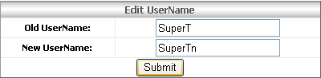
Figure 32: Edit User Name
Clear Credit: Allow authorized users to delete credit of Super, Master, Agent and Member. It also allows to reject all downline credit accounts when users clear credit of Super, Master or Agent. For example: Clear Super ‘SuperT’ credit, the downline credit account of SuperT like Master ‘SuperT02’, Agent ‘SuperT0201’, and Member ‘SuperT0201001’ also are deleted.

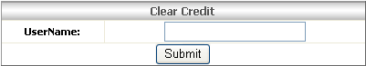
Figure 33: Clear Credit

- Change User Group: This function is used for members only. Authorized administrators allow moving each user from this group to another. Because the odds are set for difference groups, members only see odds on the group which they belong to.
- Username: Key the user name of member.
- New User Group: include category user groups such as a, b, c, or hka.

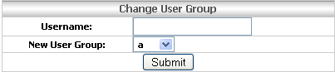
Figure 34: Change User Group

- Move Master: This function allowance moves master to new supper. When user inputs the Username of master, the system will check whether it exists in the system or not. If existed, it will allow for changing. Otherwise, it’s not. The Master and new Super have the same currency.

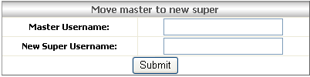
Figure 35: Move master to new Super

- Add Operator: Allow user to add more operators to control the match.
The UserName, Password, and Role text boxes are required user to input, other fields are optional, but we recommend user to enter because that information will be useful for statistic later.
[1] Role: The roles of any operator are specified from 5 to 10. The higher role operator has the more authority operator is set.
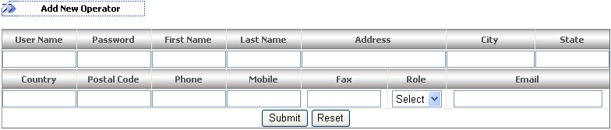
1

Figure 36: Add New Operator

- Operator List: This function lists user who controls the match. Depending on the role so user will have difference authorities.
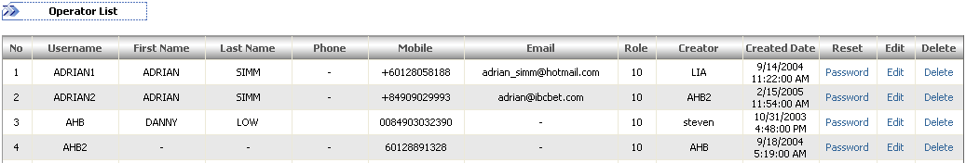
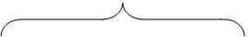
2
3
4
5
6
7
1

Figure 37: Operation List

[1] Personal Information: This part includes User Name, First Name, Last Name, Phone, Mobile, and Email.
[2] Creator: Display the name of a person who creates the operation information
[3] Reset Password: User can reset his/her password by clicking the “Password” link
Password: Input the new password.
Confirm password: Retype the password and then click Submit button to finish or click Cancel to quit the process.
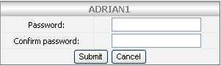

Figure 38: Set password

[4] Edit: This function allows user to edit personal information like First name, Last Name or Role… etc.

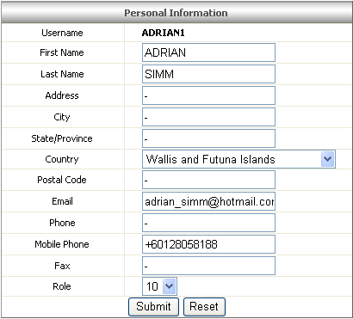

Figure 39: Personal Information
[5] Delete: Allow deleting the operation when click on Delete link. Before user can delete, there is a message to confirm that whether you want to delete or not. If you click on OK that means you accept otherwise cancel process.

Event

Allow authorized user to control Team Lists, Leagues, Event List, Parlay, and Outright.

Team List: can be managed very easily by just clicking the “Team List” link and can be used in many difference functions illustrated below:

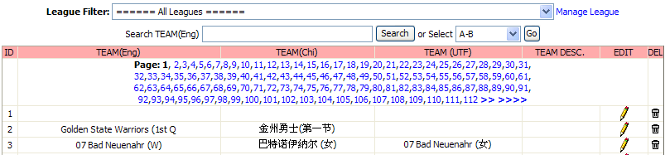
1
7
3
4
5
2
6
9
8

Figure 40: Team List

[1] League Filter: provides one place where to select specific league in order to view and control all teams belong to that league.
[2] Team (Eng): displays the team name in English.
[3] Search Team (Eng): is a place where user can enter the team name and then click “Search” button to view the team based on that team name.
[4] Team (Ch): shows the team name in Chinese Simplified.
[5] Team (UTF): shows the team name in Chinese Traditional.
[6] Team Desc: deeply description about that specific team.
[7] Manage League: provides much useful function in order to manage Leagues by clicking the “Manage League” link.
League: Select the specify league from the drop down list. Team not in this league: List all teams which haven’t belonged to that selected league.
ADD: This button enforces the selection of user: choosing which team will be added to that selected league.
REMOVE: Remove the team out of that selected league.

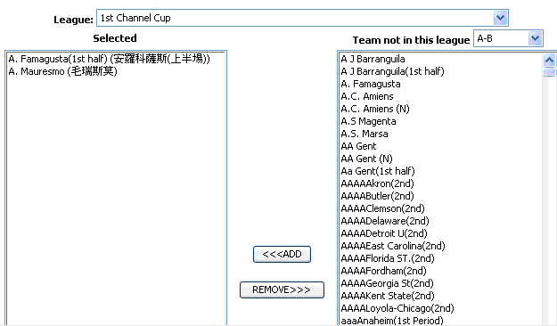

Figure 41: Add Team to League

[8] Edit: is very useful feature allowed authorized user to edit particular team information by clicking on edit icon. The message “Are you sure to edit this team?” will be displayed and then click “OK” to continue. Otherwise, click “Cancel” to quit editing.
[9] Del: when the team does not exist any more or for some reasons, administrators also can delete it by click on delete icon.

Add New Team: Administrators have permission to add more teams into the system in order to create the diversified betting for customers.

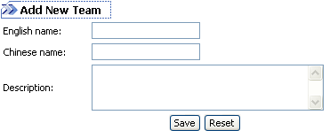
Figure 42: Add New Team

Leagues: The main functionality of Leagues is allowance to add more leagues to leagues list (Figure 36 below).
[1] Sport Type: includes sport category Soccer, Basketball, Volleyball, or Tennis.
[2] League (Eng): The name of league in English.
[3] League (Big5): The name of league in Chinese.
[4] Max Stake (Hdp): The maximum handicap stake per league.
[5] Max Stake (OU): The maximum over/under stake per league.
[6] Max Stake (OE): The maximum odd/even stake per league.
[7] Color: The heading color of league which is presented in the member site.
[8] Edit: Edit the league information.
League Info: admin can edit general league information like Select default setting (the priority of the league for instance Major League Setting, Minor League Setting, or Small League Setting), English Name, Chinese Name, Chinese Name (Unicode), and Color.
Handicap: allow admin sets the Min, Max, Risk, Range, Gap Odds, and Gap Odds (Risk) for handicap bet type over the league.
Over/Under: allow admin sets the Min, Max, Risk, Range, Gap Odds, and Gap Odds (Risk) for Over/Under bet type over the league.
Odd/Even: allow admin sets the Min, Max, Risk, Range, Gap Odds for Odd/Even bet type over the league.
Correct Score: allow admin sets the Min, Max, Risk, Range, Gap Odds for Correct Score bet type over the league.
1x2:
Total Goal: allow admin sets the Min, Max, Risk, Range, and Gap Odds for Total Goal bet type over the league.
Half-time Hdp: allow admin sets the Min, Max, Risk, Range, Gap Odds, and Gap Odds (Risk) for half-time handicap bet type over the league.
Half-time 1x2: allow admin sets the Min, Max, Risk, Range, and Gap Odds for half-time 1x2 bet type over the league.

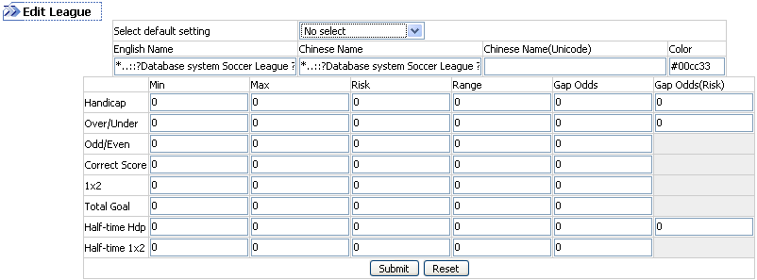
Figure 43: Edit League List

Del: Click on icon admin can delete all information relation to the league.

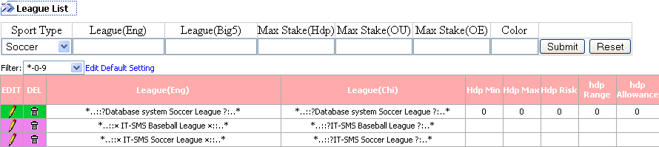
7
6
1
5
4
3
2
8

Figure 44: League List

Event List: Most important of this part is managed all events which are running, closed, postponed or internal. From the League Filter drop down list, user can select the league that he/she wants.
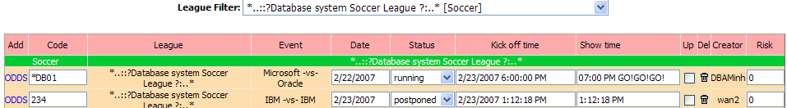
1
2
3
4
5
6
7
8
9
12
10
11

Figure 45: Event List

[1] Add: provides a very important feature allowed authorized user creating new odds for particular match by clicking any “ODDS” link at the Add column.
[2] Code: the identification code of each particular match.
[3] League: verifies the league of each match.
[4] Event: shows the teams of each specific match.
[5] Date: sets the date which the game will be shown.
[6] Status: specifies the situation of each match:
Running: the match will appear to wagers and then they can view or bet.
Closed: The match will be closed to wagers and they can’t view or bet.
Postponed: The match will be delayed to wagers and the odd is no more offer; they can view but can’t bet.
Internal: The match does not appear to wagers, but user still can bet though the Phone still appear in the Admin’s Phone Betting area. Therefore, the Admin user will be able to key tickets in. This status will be used when we want to close match for wagers but still need to key some “hedge” bet information into system.
[7] Kick off time: the start date and time of that match which is saved on server. The convenient for admin doing the report is that the kick off time always plusses 12 hours.

Event | Kick off time | Show time
R.Betis –vs- Sevilla | 2/10/2007 4:59:00 PM | 02/11 05:00AM

[8] Show time: This is the real time which the event will be shown and the wager can see that match at the member site.
[9] Update: provides one function for user updating specific event by checking any check box at the Up column and then clicking the Update button.
[10] Delete: allows authorized user to delete any event by clicking the delete icon. The message “Are you sure to remove this event?” will be displayed. Click “OK” to continue deleting. Otherwise, click “Cancel” to quit.
[11] Creator: displays the name of a person who creates the event information.
[12] Risk: sets the percentage that company prefers to take for the external admin per each match.

Add Event: mainly provides one single place where authorized user add new event for preferred league.

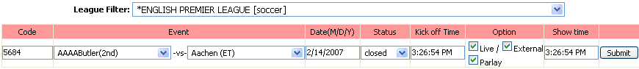
2
1
3
4
5
6
7
8

Figure 46: Add Event

[1] Code: verify the code for new event.
[2] League Filter: Identify the league which user wants to add to new event.
[3] Event: select the team names which join that event.
[4] Date (M/D/Y): set the date that the game will show.
[5] Status: the status of that event “Closed’ or “Running”.
[6] Kick off Time: the game time could be shown.
[7] Option: Set the types betting for that event:
Live: Allow the wagers placed their bets on Live Betting type (Full Time or 1st Half Time).
External: This option means that we can’t view game live on broadcast; we have to ask agents monitoring for us and then we give commission to them (about 40% per each event).
Parlay: Allow the wagers placed their bets on Parlay type.
[8] Show Time: Input the real shown time of that event in which player can view and bet on member sites.

For example: The figure above shows that admin has been chosen the *English Premer League [Soccer] on the League Filter dropdown list. The code of that event is 5684; the team names which join the event are AAAABultler (2nd) –vs- Aachen (ET). The event will be shown on 2/14/2007 with Status is “Closed”. The Kick off Time is 3:26:54 PM and the Options of that event are Live, External, and Parlay.

Note: If the league hasn’t included the team names yet, the message “There is no team in this league. Please click HERE to put team under this league or click HERE to show all team names” will be displayed at the Event column. Prefer to Team List for more specific details.

Parlay Control: This function allows administrator setting events which players can place the bets on Parlay bet type by checking on the check box at the right side of the event.

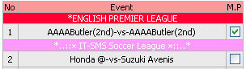
Figure 47: Parlay control

Outright: provide much useful function allowed authorized user to manage the Outright bet type.
1
2
3
4
6
8
9
5
7

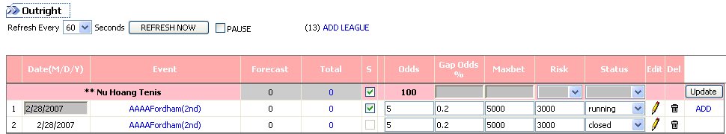

Figure 48: Outright

[1] Event: Settle Outright of the event, this function allows admin to set the odds status. E.g. the event is running, closed, or won.
[2] Forecast: show the potential values that players will win or lose per team.
[3] Total: The total amount that players bet on that team. When user clicks on this number, the Team List page will show the detail information like Account, Bet, Odds, Currency, Amount, Reference number, Creator and Time.
[4] S: The unchecked default means that the event is running. Otherwise, means suspended. The system will automatically postpone one team or all teams within 1 second after user checks on any checkbox at S column without pressing the Update button.
[5] Gap Odds: Show the percentage of odds that every time the odds increase or decrease. Ex: if the Gap Odds is 0.2% and the odds are 20, each time the odds increase to 20.002 otherwise will be 19.998.
[6] Max bet: The maximum amount that the wager can place a bet per each bet.
[7] Risk: the percentage of risk that company allowed per each match.
[8] Status: The status of the event which is still running, closed, or suspend.
[9] Add: Allow admin added more events to the league.

5. Setting: Administrator users can access to this function in order to assign permission to authorized users for controlling the leagues and total bets.

- Permission on Leagues: specify sets of users that have limited access to the leagues. In practice the limited access means that users should generally control only leagues that are assigned by the Administrator User. Illustrated at Figure….. below:

[1] User: show the admin username.
[2] Edit: click any “Edit” link to assign permission on leagues for each user. Every individual user can be assigned responsible for more than one league to manage.
[3] List all selected leagues for each individual user. This function also allows you to undo selected league for that user.
[4] Go: click “Go” to submit your selected or unselected leagues.
[5] List all unselected leagues and also allow you to choose the leagues assigned for each user.
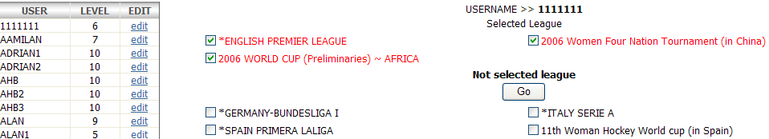
1
2
3
4
5

Figure 49: Permission on Leagues

- Permission on Total Bet: The administrator user having limit access right to this session will be clarified by viewing the message “You do not have permission to access this page”. This feature also provides a place where authorized user enables to set permission for the others managing the total bets.

[1] Top: If the user stands on “Top”, he will have full permissions, those are selection all bet types for all matches, all bet types for this match, Handicap for all matches, Over/Under for all matches, HDP and 1st HDP for this match, O/U and 1st O/U for this match or this selection only, in order to control the total bet.
[2] Grant: can see and control total bet for that particular match even though the Top user would like to disable its.
[3] Normal: can only see and control total bet when the Top user enables the match.

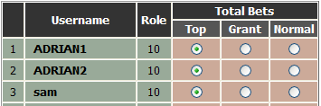
Figure 50: Permission on Total Bet

- Add Rule & Regulation: user can create new Rule and Regulation via the Add Rule & Regulation menu. Illustrated in the Figure… below:

Site: provides category sites, included 789y, indo, s333bet, king119, Trojan, and so on, for user chosen to add the new rule & regulation on that particular site.
Language: click the “Language” dropdown list to get the category languages such as English, Chinese (Simplified), Chinese (Traditional), Japanese, and Thai.
Text: is a place to key in the content for that rule & regulation.

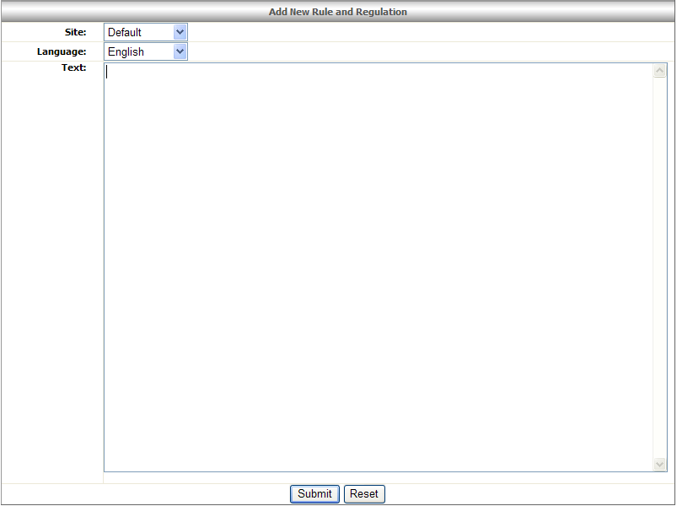

Figure 51: Add New Rule and Regulation

Rule & Regulation List: This page show all rules and regulations about the betting or using site.

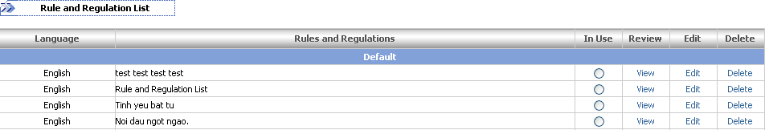
1
2
3
4
5
6
Figure 52: Rules and Regulation

[1] Language: The language used for rules and regulations such as English, Japanese, or Thailand.
[2] Rules and Regulations: Display the content of rules and regulations.
[3] In Use: Show the status of rules and regulations are in using or not.
[4] Review: Allow user to view rule and regulation in detail.
    - Site: identify which site this rule and regulation used for.
    - Language: language of rule and regulation.
    - In use: status of rule and regulation in use or not.
    - Text: Content of rule and regulation.

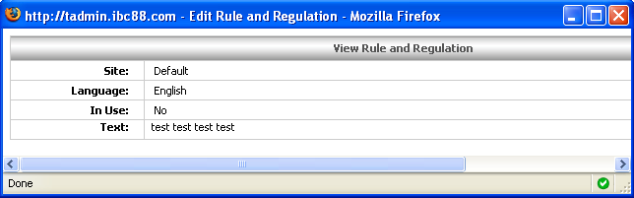
Figure 53: View Rule and Regulation

[5] Edit: When click on the Edit link function use can edit the In Use status and the content of rule and regulation information (Text)

[6] Delete: Click on Delete link to delete any rule and regulation.

6. Tools

- Odds Calculator: enables you to convert odds from 1x2 to Handicap bet type.

All of the HDP setting values, showed at the following Table…, must be based on the limit of Min and Max values. Min value specifies the value you want to use to calculate the odds and specify min value setting for HDP. Max value specifies the maximum value used for setting HDP.

Min Value | Max Value | HDP
0 | 1.3 | 0
1.5 | 1.8 | 0.25
2 | 2.55 | 0.5
3 | 3.65 | 0.75
4 | 4.6 | 1
5 | 5.65 | 1.25
6 | 6.6 | 1.5
7 | 7.6 | 1.75
8 | 8.65 | 2
9 | 9.65 | 2.25
10 | 10.65 | 2.5

Figure 54: HDP Setting Values

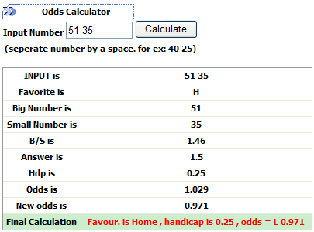
Figure 55: Odds Calculator

- Input Number: The inputted numbers must be separated by a space, e.g. 51 35.
- Favorite: If the first number is greater than the second, “H” will be displayed. Otherwise, “A” will be displayed.
- Big Number: show big number that the user entered.
- Small Number: show small number that the user entered.
- B/S: Big Number divided by Small Number is B/S.
- Answer: after we have B/S value, we will know the “Answer” value according to the limit of the Min Value and Max Value at the Table… e.g. B/S = 1.46, Min Value = 1.5, Max Value = 1.8 ==> Answer = Min Value = 1.5
- HDP: show the Handicap value. Ex: B/S = 1.46, Min Value = 1.5, Max Value = 1.8, Answer = Min Value = 1.5 ==> HDP = 0.25
- Odds: display the odds for Handicap bet type. Formulas: if Odds > 1 the New Odds = 1/Odds; If Handicap = 0 then Odds = Small Number / Big Number. Otherwise, Odds = Min Value / B/S.
- New Odds: display the odds with “-“signed at the member site. This function just applies when the Odds > 1.

- Statistic

Enable users view betting status of members. Bet lists information just exists for a sort time in the current.

  - Current Bets: list all current bets of members which are based on the Stake value. We can sort bets by stake value that greater than 0, 10, 50, 100, or 1000.

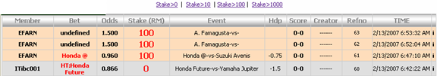
Figure 56: Current Bets

- Member: the member’s username of each bet transaction. e.g. ITibc001
- Bet: Display the bet type except Handicap type. For the Handicap, the system will show the team name of the members’ selection.
- Odds: odds value of the selected bet type.
- Cur: The Currency of user’s credit but in this pages it usually is RM.
- Amount: total amount of money in each bet transaction placed by member.
- Event: The teams of each bet transaction.
- Hdp: shows the value of the favorite team that was given the handicap.
- Score: the current score when bet was placed. Moreover, the current score might fluctuate during a live game.
- Creator: Present the username of customer who creates the bet if user bets though Internet.
- Refno: The reference number of each bet transaction. e.g. 315
- Time: The date and time of each bet transaction was accepted by the system.
- Bet from: Identify whether the wagers placed the bet on “I” = internet, “p” = phone, or “wp” = WAP.

  - Last Bets: list bets based on All Bettype, Handicap, Over/Under, Others Bettype, Select League, 10, 20, 30, and 50.

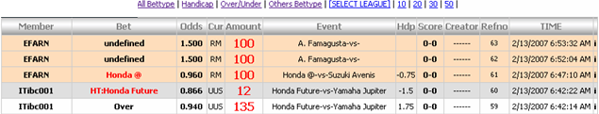
1
2
3
4
5
6

Figure 57: Last Bets

- [1] All Bettype: List all bets which don’t distinguish bet type.
- [2] Handicap: Show all bets which are betted on the Handicap bet type.
- [3] Over/Under: Show all bets which are betted on Over or Under bet type.
- [4] Others Bettype: List all bets which are betted on Correct Score, Total Goal, Mix Parlay, or Outright bet type.
- [5]Select League: Enable user view bet lists based on selected leagues that have Today Games.
- [6] 10| 20| 30| 50|: List bets which are sorted by number 10, 20, 30, or 50 and must be implemented by all or particular bet type.

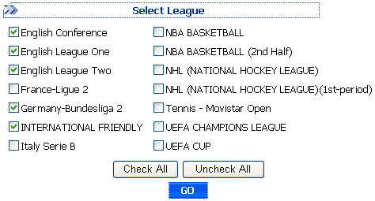
Figure 58: Select League

Note: On Last Bets, there have Currency and Amount columns which list the currency such as RM, UUS, or RMB, and the stake amount while on the Current Bets, all amount will be exchange to RM currency on Stake column.

Appendices

